ANOTIDAISHE BLESSED ZHOU
25/SCA/BCDS/019
WEB TECH ASSIGNMENT

- CALCULATOR
<html>
<head>
<title>
calculator
</title>
<script>
function appendVAL(X) {
y= document.getElementById('total').value;

document.getElementById('total').value=y+X ;
}

function calculate() {
X= document.getElementById('total').value;
document.getElementById('total').value=eval(X) ;
} ;
</script>
<style>
body{
text-align: center;
background: linear-gradient(to right,purple,blue);
font-family: 'Lucida Sans', 'Lucida Sans Regular', 'Lucida Grande', 'Lucida Sans Unicode', Geneva, Verdana, sans-serif;
color:rgb(0, 0, 0);
align-items: center;

}
table{
border-radius: 10px;
padding: 20px;
width: 400px;
height: 550px;
background: rgb(148, 159, 163);
box-sizing: border-box;
}

/* Make buttons and inputs fill their table cell containers */
table { border-collapse: separate; border-spacing: 6px; }
td { padding: 0; }
input[type="button"], button, input[type="reset"] {
width: 100%;
height: 100%;
box-sizing: border-box;
font-size: 18px;
padding: 12px 8px;
border: none;
background: #eee;
cursor: pointer;
}
input[type="button"]:active, button:active, input[type="reset"]:active { transform: translateY(1px); }

/* Give each cell a consistent height so buttons can fill it */
tr > td { height: 64px; }

/* Input display at top */
#total { width: 100%; height: 56px; font-size: 20px; padding: 8px; box-sizing: border-box; }
</style>
</head>
<body>
<h1>CALCULATOR</h1>
<center>
<table border="3" >
<tr>
<td colspan="5"><input type="text" id="total" ></td>
</tr>
<tr>
<td> <input type="button" value="1" onclick="appendVAL('1')"> </td>
<td> <input type="button" value="2" onclick="appendVAL('2')"> </td>
<td> <input type="button" value="3" onclick="appendVAL('3')"> </td>
<td> <input type="button" value="/" onclick="appendVAL('/')"> </td>
</tr>
<tr>
<td> <input type="button" value="4" onclick="appendVAL('4')"> </td>
<td> <input type="button" value="5" onclick="appendVAL('5')"> </td>
<td> <input type="button" value="6" onclick="appendVAL('6')"> </td>
<td> <input type="button" value="+" onclick="appendVAL('+')"> </td>
</tr>
<tr >
<td> <input type="button" value="7" onclick="appendVAL('7')"> </td>
<td> <input type="button" value="8" onclick="appendVAL('8')"> </td>
<td> <input type="button" value="9" onclick="appendVAL('9')"> </td>
<td> <input type="button" value="-" onclick="appendVAL('-')"> </td>
</tr>
<tr>
<td> <input type="button" value="0" onclick="appendVAL('0')"> </td>
<td > <input type="button" value="" onclick="appendVAL('')"> </td>
<td colspan="2"> <button type="reset">CLEAR </td>

</tr>
<tr >
<td colspan="5"> <input type="button" value="=" onclick="calculate()"> </td>
</tr>
</table>
</center>
</body>
</html>

OUTPUT

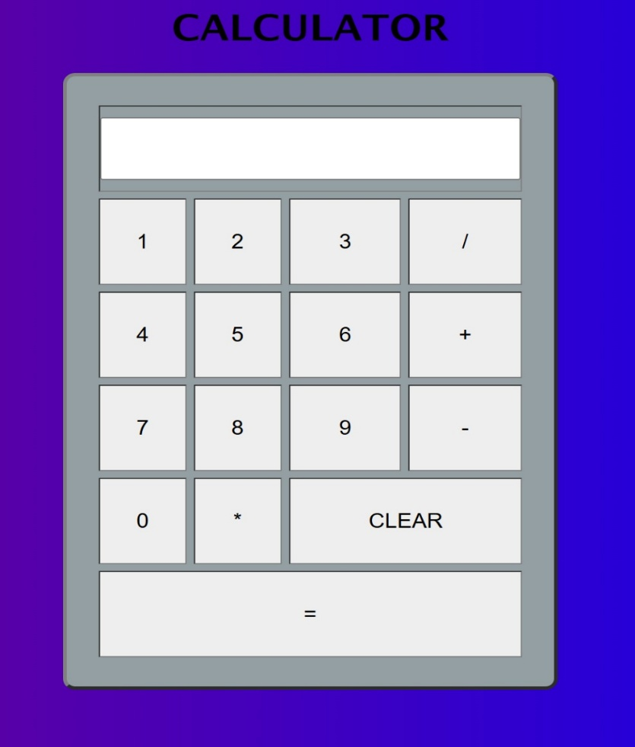

- ROWSPAN, COLSPAN AND CELLPADDING, CELLSPACING
<html>
<head>
<title> PRACTICE 12</title>
</head>
<!--demo: colspan and rowspan-->
<Body bgcolor="lightyellow">
<header align="center">
<h1>PRACTICE 12</h1>
</header>
<table border="4" width="400" height="300" align="center" bgcolor="skyblue" cellpading="10" cellspacing="5">
<tr>
<td rowspan="2" colspan="2" align="center"> 1 </td>
<td colspan="2" align="center">2</td>
</tr>

<tr>
<td colspan="2" align="center">3</td>
</tr>
<tr>
<td colspan="2" align="center">4</td>
<td colspan="2" align="center">5</td>
</tr>
<tr>
<td align="center">6</td>
<td align="center">7</td>
<td align="center">8</td>
<td align="center">9</td>

</tr>
<tr align="center">
<td>10</td>
<td colspan="2">11</td>
<td>12</td>
</tr>
</table>
</table>

<!-- Demo: cellpadding and cellspacing -->
<hr>
<section align="center">
<h2>Table spacing demo</h2>
<p>This example shows a table with <code>cellpadding</code> (space inside cells)
and <code>cellspacing</code> (space between cells). Below it is a table without
those attributes for comparison.</p>

<h3>With cellpadding="12" and cellspacing="8"</h3>
<table border="1" cellpadding="12" cellspacing="8" align="center">
<tr>
<th>Header 1</th>
<th>Header 2</th>
</tr>
<tr>
<td>Cell A1</td>
<td>Cell A2</td>
</tr>
<tr>
<td>Cell B1</td>
<td>Cell B2</td>
</tr>
</table>

<h3>Without cellpadding / cellspacing (default)</h3>
<table border="1" align="center">
<tr>
<th>Header 1</th>
<th>Header 2</th>
</tr>
<tr>
<td>Cell A1</td>
<td>Cell A2</td>
</tr>
<tr>
<td>Cell B1</td>
<td>Cell B2</td>
</tr>
</table>

<p style="max-width:600px; text-align:left; margin:12px auto;">
Note: In HTML5 the <code>cellpadding</code> and <code>cellspacing</code> attributes
are considered presentational and CSS (for example, <code>padding</code> on
<code>td</code> and <code>border-spacing</code>) is preferred. However,
these attributes still work in most browsers and are shown here for learning.
</p>
</section>

</Body>

</html>

OUTPUT
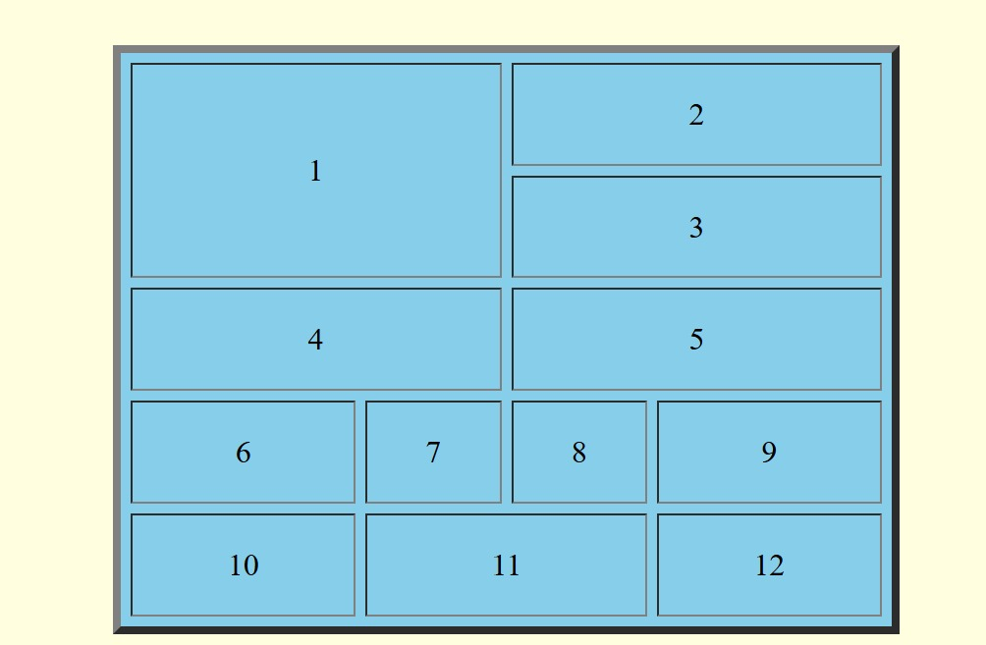

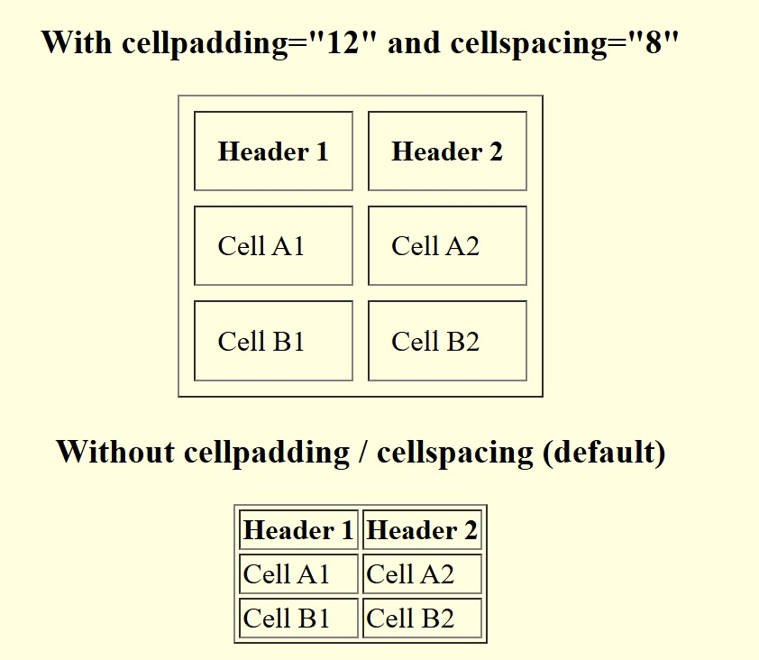

- GROCERY STORE
<DOCTYPE html>
<html>
<head>
<script>
function cal1(){
var Qty=document.getElementById("Q1").value;
var amt=eval(Qty*80);
document.getElementById("div1").innerHTML=amt;
document.getElementById("Gross").innerHTML=eval(amt+"+"+document.getElementById("Gross").innerHTML);
}
function cal2(){
var Qty=document.getElementById("Q2").value;
var amt=eval(Qty*40);
document.getElementById("div2").innerHTML=amt;
document.getElementById("Gross").innerHTML=eval(amt+"+"+document.getElementById("Gross").innerHTML);
}
function cal3(){
var Qty=document.getElementById("Q3").value;
var amt=eval(Qty*35);
document.getElementById("div3").innerHTML=amt;
document.getElementById("Gross").innerHTML=eval(amt+"+"+document.getElementById("Gross").innerHTML);
}
function cal4(){
var Qty=document.getElementById("Q4").value;
var amt=eval(Qty*45);
document.getElementById("div4").innerHTML=amt;
document.getElementById("Gross").innerHTML=eval(amt+"+"+document.getElementById("Gross").innerHTML);
}

</script>

<title>RMC Grocery Store</title> </head>
<body bgcolor="aqua">

<h1><center>
Grocery Store
</center>
</h1>
<center>
<table border="5" >
<tr>
<th>Sr#</th>
<th>Item</th>
<th>Price/Unit</th>
<th>Qty</th>
<th>Amount</th>
</tr>
<tr>
<td>1</td>
<td>Rice</td>
<td>80 INR/Kg</td>
<td><input type="text" id="Q1" onchange="cal1();"></td>
<td><div id="div1">0</div></td>
</tr>
<tr>
<td>2</td>
<td>Wheat</td>
<td>40 INR/Kg</td>
<td><input type="text" id="Q2" onchange="cal2();"></td>
<td><div id="div2">0</div></td>
</tr>
<tr>
<td>3</td>
<td>Hair Oil</td>
<td>35 INR/Kg</td>
<td><input type="text" id="Q3" onchange="cal3();"></td>
<td><div id="div3">0</div></td>
</tr>
<tr>
<td>4</td>
<td>Soap</td>
<td>45 INR/Kg</td>
<td><input type="text" id="Q4" onchange="cal4();"></td>
<td><div id="div4">0</div></td>
</tr>
<tr>
<td colspan="3"> Total Bill Amount(INR)</td>
<td colspan="2" > <center>
<div id="Gross">0</div></td>
</center>
</tr>

</table>
</center>
</body>

</html>

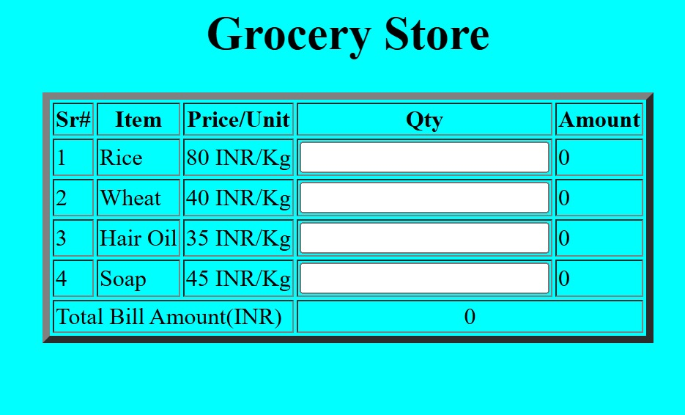

- COLOR OUTPUT
<!DOCTYPE html>
<html>
<head><title>Color Output from 1 to 10 </title></head>

<h1><u>Showing Different color output from 1 to 10</u></h1>
<body bgcolor="aqua">

<p style="color: aqua;">1 <br></p>
<p style="color: blueviolet;">2 <br></p>
<p style="color: blue;">3<br></p>
<p style="color: black;"> 4 <br></p>
<p style="color: rgb(42, 165, 63);"> 5 <br></p>
<p style="color: rgb(237, 253, 7);"> 6 <br></p>
<p style="color: rgb(180, 5, 180);"> 7 <br></p>
<p style="color: rgb(240, 5, 5);"> 8 <br></p>
<p style="color: rgb(14, 209, 112);"> 9 <br></p>
<p style="color: rgb(216, 75, 19);"> 10 <br></p>

</body>

</html>

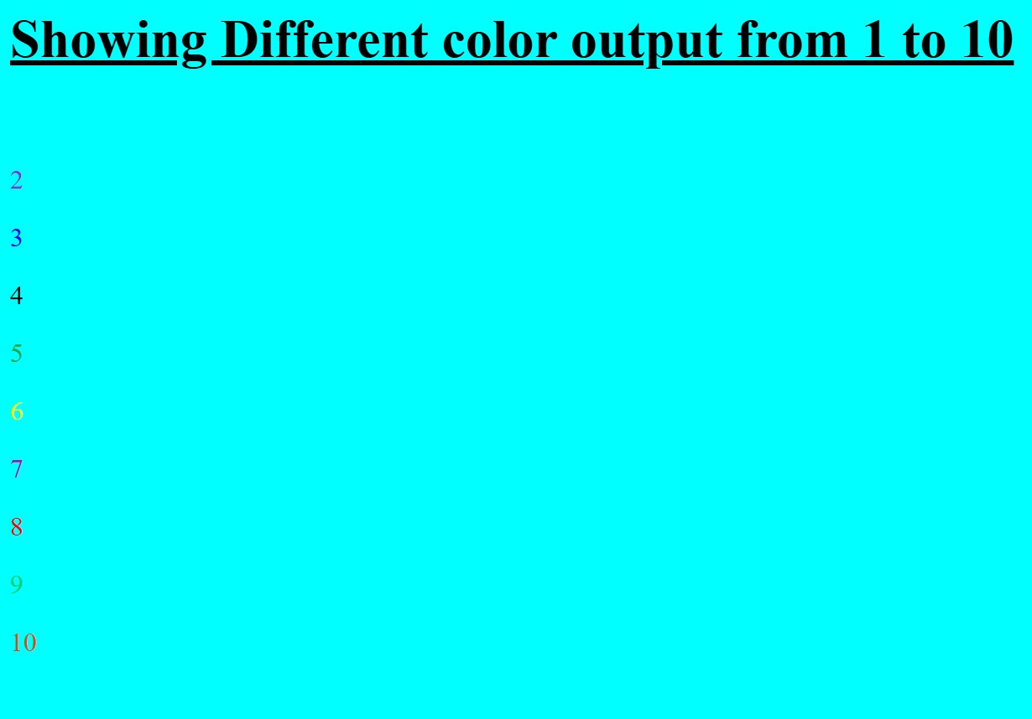

- DISPLAY MY NAME
<!DOCTYPE html>
<html>
<head><title>Displaying name on screen</title></head>

<h1><u>Displaying my name</u></h1>
<body bgcolor="aqua">
<p>My name is Anotidaishe Blessed Zhou</p>
</body>

</html>

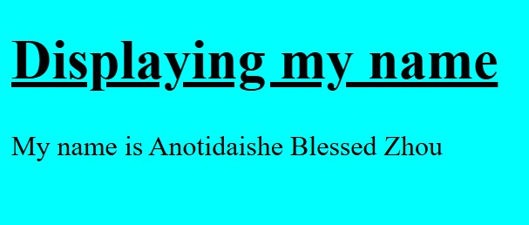

- HEARDING SIZE
<!DOCTYPE html>
<html>
<head><title>Heading TAG</title></head>
<h1><u>Heading Tag Sizes</u></h1>
<body bgcolor="aqua">
<p>
<h2>R</h2> <h3>O</h3><h4>N</h4> <h5>A</h5> <h6>L</h6><h7>D</h7>
</p>
</body>
</html>
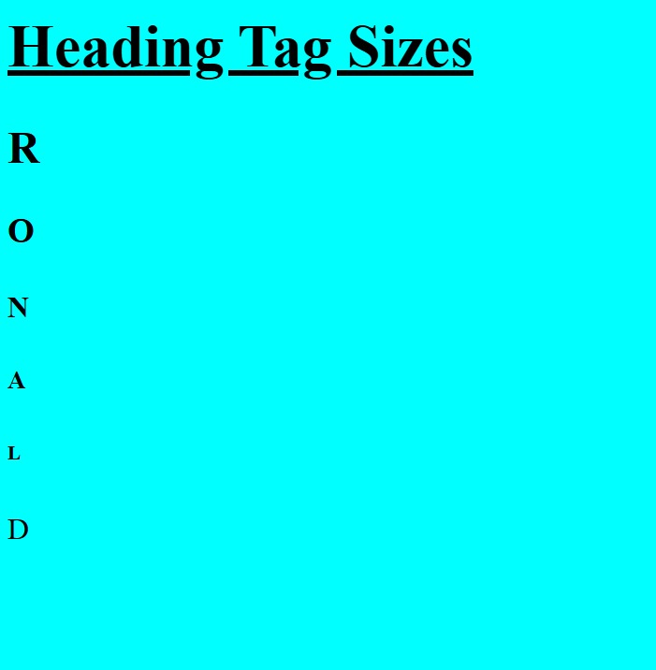

- LIST
<!DOCTYPE html>
<html>
<head><title>Output from 1 to 10 </title></head>

<h1><u>Showing Output from 1 to 10</u></h1>
<body bgcolor="aqua">
<p>
1 <br>
2 <br>
3 <br>
4 <br>
5 <br>
6 <br>
7 <br>
8 <br>
9 <br>
10 <br>
</p>
</body>
</html>

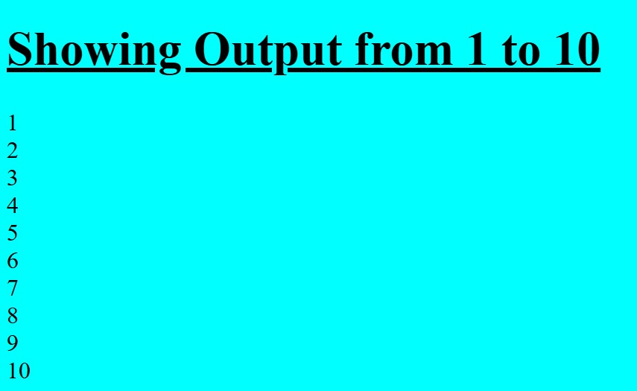

- NODE.JS
DATA.JSON
[
{"id":1,"first_name":"Shirl","last_name":"Faltin","email":"sfaltin0@icio.us"},
{"id":2,"first_name":"Deane","last_name":"Kaines","email":"dkaines1@indiatimes.com"},
{"id":3,"first_name":"Brianna","last_name":"Guiden","email":"bguiden2@sciencedaily.com"},
{"id":4,"first_name":"Arvy","last_name":"Sneezum","email":"asneezum3@typepad.com"},
{"id":5,"first_name":"Andee","last_name":"Witherow","email":"awitherow4@abc.net.au"},
{"id":6,"first_name":"Eduino","last_name":"Bertholin","email":"ebertholin5@un.org"},
{"id":7,"first_name":"Zelig","last_name":"Eck","email":"zeck6@sciencedirect.com"},
{"id":8,"first_name":"Jacquelin","last_name":"Klemenz","email":"jklemenz7@shareasale.com"},
{"id":9,"first_name":"Quintina","last_name":"Cato","email":"qcato8@erecht24.de"},
{"id":10,"first_name":"Sheryl","last_name":"Ayton","email":"sayton9@ca.gov"}
]

SECOND.JS
const express = require('express');
const data = require('./data.json');

const app = express();
const PORT = 3000;

app.get('/', (req, res) => {
res.json(data);
});

app.get('/class/:id', (req, res) => {
const studId = Number(req.params.id);
const student = data.filter((student) => student.id == studId);
res.json(student);
console.log(req.params);
});

app.listen(PORT, () => {
console.log(The server is running on port number ${PORT});
console.log('json data captured successfully');
});

